Linux – How to Install a different Desktop Environments
Dan Richter
10 Sep 2020

Now that you’ve seen a few different DEs, you probably found one that you would like to install on your system, so that you can check it out. Well, you’re in luck. It is actually pretty simple to do this. Keep in mind, that sometime one DE doesn’t work well with another on the same system. This is usually solved by removing one or the other. It doesn’t happen often, but it does happen.

For this writing, I’m going to assume that you are running a Debian based system. The following will work with any system, but the terminal commands will utilize APT. If you are running something else, you will have to adapt your terminal commands to fit the package manager you are using.

Also, the pictures used in this writing will be stolen from a www.howtogeek.com article, as I don’t have easy access to grab screenshots from a Debian system.

If you are running Ubuntu, go into your ‘Ubuntu Software Centre’. If you are in Debian, go into the ‘Synaptic Package Manager’. Linux Mink will open the ‘Software Manager’. They all work similar. Click on the search field, indicated by the magnifying glass icon, and type in the name of the desktop environment you wish to download. Let’s say you are wanting to try out XFCE4. You could easily type in lxde, or kde-full, depending on which one you would like to try.

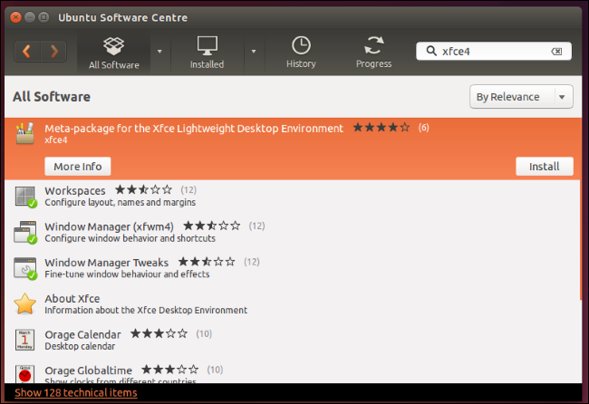

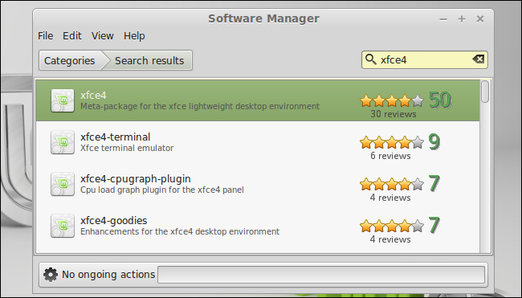
Once you have the results listed, as the above screenshots indicate, you can select them for install, and they will be installed on your computer.

This can also be accomplished via the command line, with the APT commands we talked about earlier. From the terminal, type in ‘sudo apt install xfce4’, and hit ‘Y’ or <enter> when prompted.

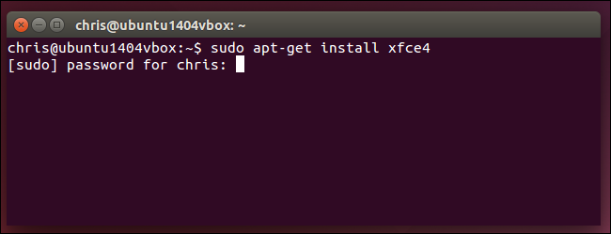

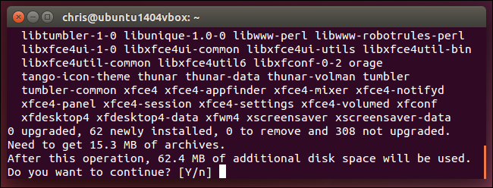
Alright, so now you have it installed on your computer, how do you change to that DE? It’s really simple. Log out of your current session. You don’t need to restart the computer, but just hit log out.

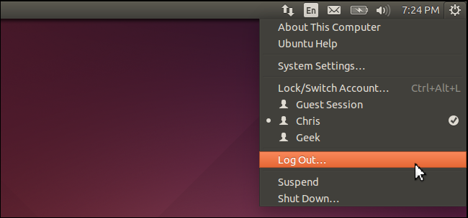
Once you are at the log on screen, where you type in your password to get into Linux, there should be a settings icon. Click on that button.

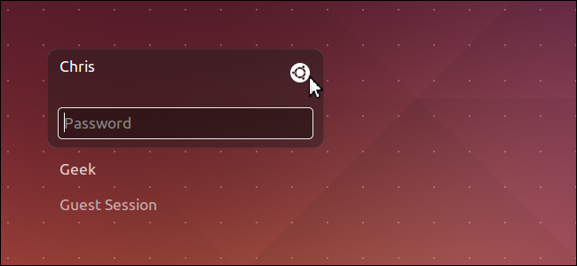
Once you click on that button, keep in mind it may look different for other desktops, you will have a list of the currently installed desktop environments on that system.

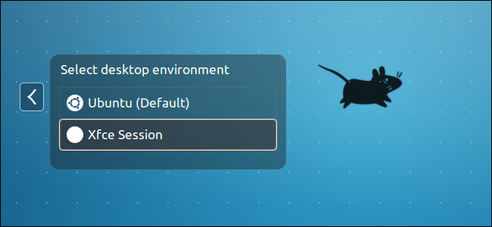
Just click on the one that you want, and it will load that DE for you.

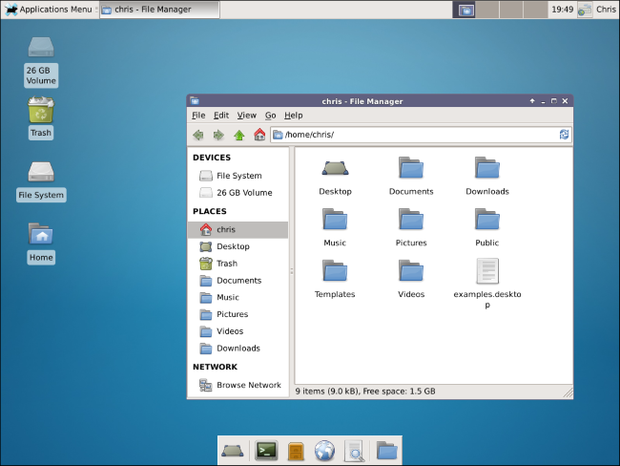
Uninstall a Desktop Environment

Now, the process for removing a desktop environment that you no longer need, is just as simple. It can either be accomplished using the Software Center available to you, or via the terminal.

From the software center, there should be a way to view all the packages that are installed on your system. If not, just do a search for the one you want to remove. For example, if you took a look at your newly installed XFCE desktop, and decided it wasn’t the one you wanted to run, you could do another search for ‘XFCE4’. It would then show that it was already installed, but it should give you an option to remove it.

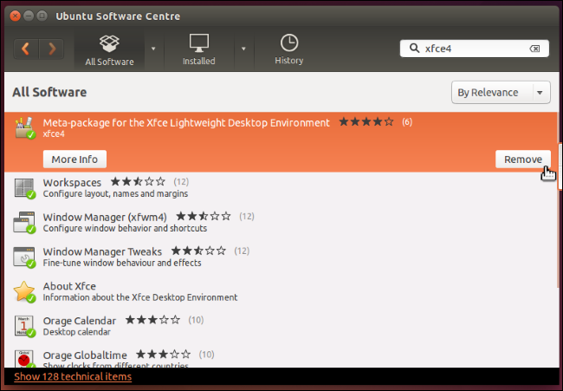
Once you have done this, it would not be a bad idea to check to make sure it removed all of the dependencies associated with the desktop environment. To do this, go to your terminal, and type in ‘sudo apt autoremove’. This command will go through all of the installed packages, and remove any that are no longer being used.

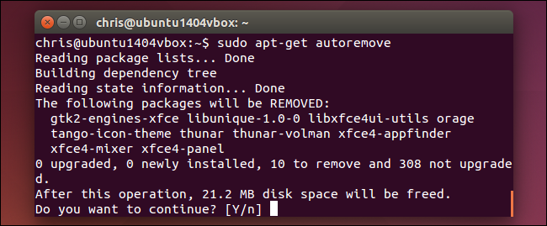
You can also do all of this from the terminal, by typing in ‘sudo apt remove xfce4’. It would also be a good idea to run the autoremove as well, just to make sure everything was removed.

